#### Family Member Popup

Nielsen’s:

**Visibility of system status ✓**

**Match between system and the real world ✓**

**User control and freedom ✓**

**Consistency and standards ✓**

**Error prevention ✓**

**Recognition rather than recall ✓**

The issue here is the same as with the shelter popup; the reasoning behind keeping it as is remains the same, too.

**Flexibility and efficiency of use ✓**

**Aesthetic and minimalist design ✓**

**Help users recognize, diagnose, and recover from errors ✓**

**Help and documentation ✓**

The issue here is the same as with the shelter popup (location may be hidden behind the popup). Once again, we hope that the popup is easy enough to close, so that the user may immediately return to the map and see the location of the

Our own:

**Offline tolerance ✓**

**Battery efficiency ✓**

**Calm computing ✓**

**Physical Simplicity ✓**

**Memory and Attention ✓**

**Attitude Towards Risk ✓**

**Communication and Collaboration✓**

#### 

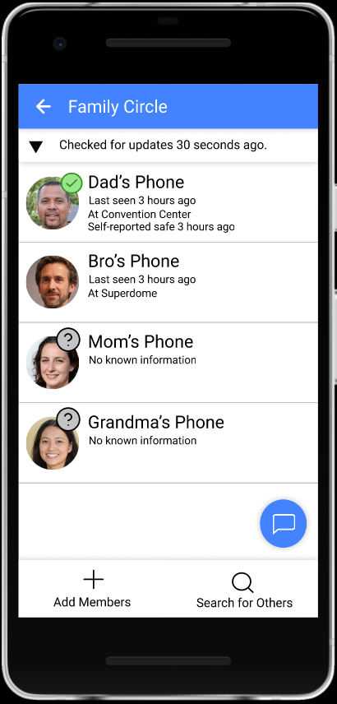

#### Family Member List

Nielsen’s:

**Visibility of system status ✓**

**Match between system and the real world ✓**

**User control and freedom ✓**

**Consistency and standards ✓**

**Error prevention ✓**

**Recognition rather than recall ✓**

**Flexibility and efficiency of use ✓**

**Aesthetic and minimalist design ✓**

**Help users recognize, diagnose, and recover from errors ✓**

**Help and documentation ✓**

Our own:

**Offline tolerance ✓**

**Battery efficiency ✓**

**Calm computing ✓**

This is a lot of information, which can be thought to go against calm computing - we might be overwhelming our users. However, the users have specifically selected this screen, and asked for more information. We thus believe that no further changes to this screen are necessary.

**Physical Simplicity ✓**

**Memory and Attention ✓**

**Attitude Towards Risk ✓**

**Communication and Collaboration✓**

#### Shelter: setting meeting point

Nielsen’s:

**Visibility of system status✓**

**Match between system and the real world✓**

**User control and freedom✓**

**Consistency and standards✓**

**Error prevention✓**

**Recognition rather than recall✓**

**Flexibility and efficiency of use✓**

**Aesthetic and minimalist design✓**

**Help users recognize, diagnose, and recover from errors✓**

**Help and documentation✓**

Our own:

**Offline Tolerance✓**

**Power Economy✓**

**Calm Computing✓**

**Memory and Attention✓**

**Physical Simplicity✓**

**Attitude Towards Risk✓**

**Communication and Collaboration✓**

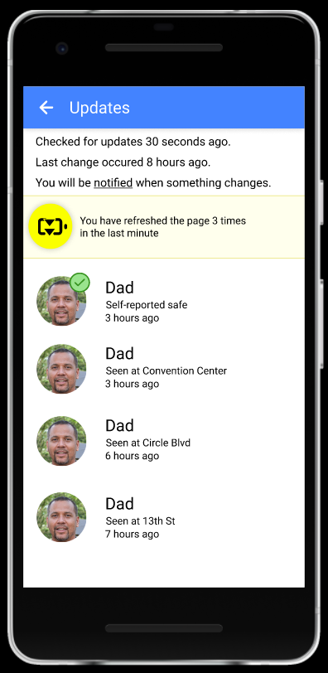

#### Update List

**Visibility of system status ✓**

**Match between system and the real world ✓**

**User control and freedom ✓**

**Consistency and standards ✓**

**Error prevention ✓**

**Recognition rather than recall ✓**

**Flexibility and efficiency of use ✓**

**Aesthetic and minimalist design ✓**

**Help users recognize, diagnose, and recover from errors ✓**

**Help and documentation ✓**

Our own:

**Offline tolerance ✓**

**Battery efficiency ✓**

**Calm computing ✓**

**Physical Simplicity ✓**

**Memory and Attention ✓**

**Attitude Towards Risk ✓**

**Communication and Collaboration✓**